PUTTING AN ABSENCE IN SMART FINDER
Step 1
Log onto LogOn | SmartFind Express | PowerSchool (eschoolsolutions.com)

Step 2
Put in your log in information. If you do not know, contact HR Sub Desk for help. For Certificate, you will need to call (559) 457-3492. For Classified, you will need to call (559) 457-3475
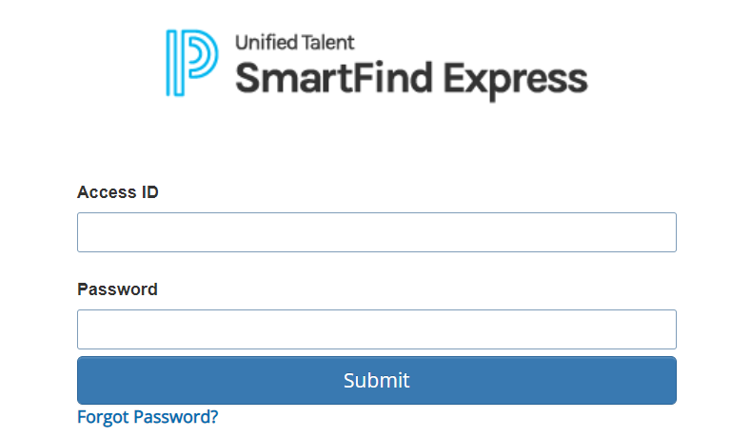

Step 3
Go to create an absent located on the top.
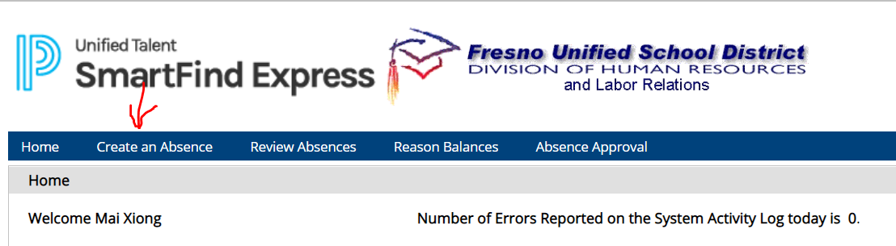

Step 4
On the next screen, make sure your location is set to the right school, your classification has your grade level/subject/title. If it does not, you can either call the HR help desk on the number provided on step 2 or you can email Rosemary Hildago1 and Laura Yates for Certificate. If are Classified, you can email Rosemary Hildago1 and Melissa Duarte.
You will put in the reason for the absent by selecting the drop-down option and then select the date(s) you are out. You do not need to add anything for the event number.
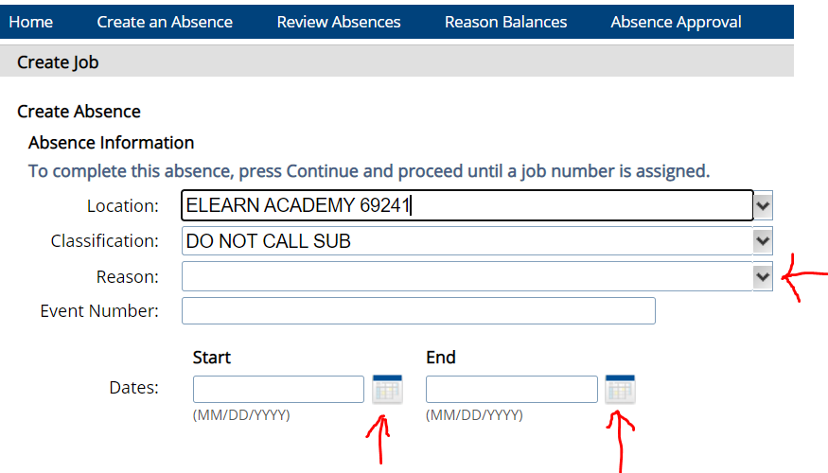
Step 5
Make sure to input the correct times you will be needing off. If you are only needing half day, put the times you will be gone. If it is the whole day, make sure the time covers the whole class.
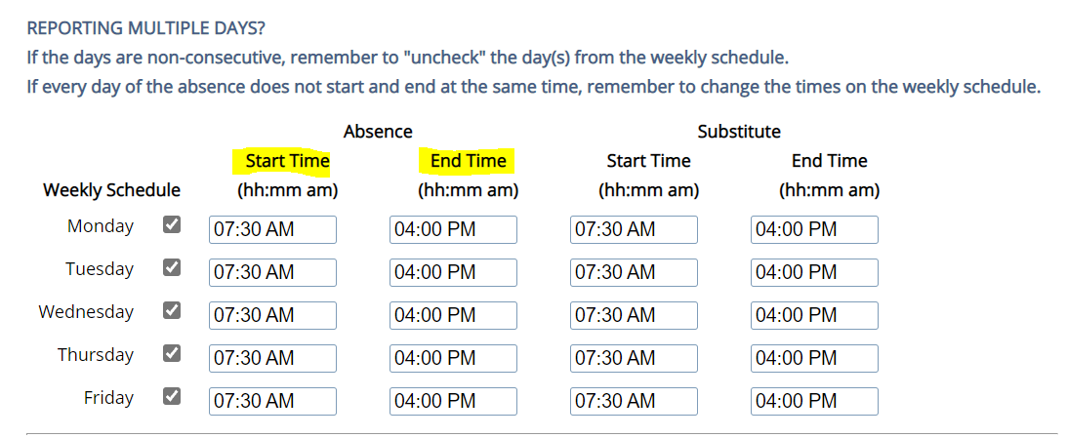

Step 6
If you already have a sub who is going to cover your class, you can put them in on the Substitute section. Make sure that after you select the sub that is covering your class, you check mark yes on the “Pre-arranged section. If you do not have a sub, you can skip this part.
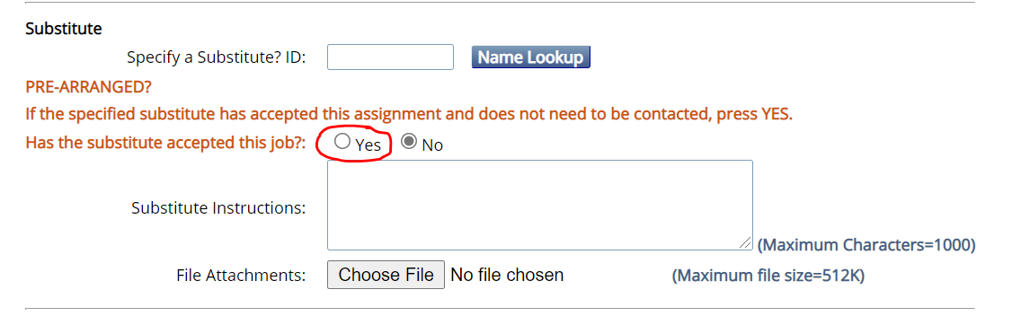

Step 7
Hit the Continue Button on the bottom left of the page.
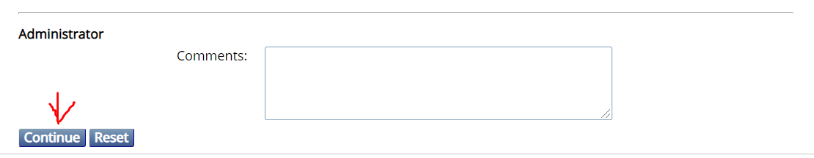

Step 8
Double check that all information is correct. If it is, hit “Create Absence”. The system will start calling out for subs.
